**LAB REPORT # 5**

Fall 2023

Data Analytics Lab

**Submitted by:**

Maaz Habib

**Registration No.:**

20PWCSE1952

**Class Section:**

C

**“On my honor, as student of University of Engineering and Technology, I have neither given nor received unauthorized assistance on this academic work.”**

**Submitted to:**

**Ma’am Madiha**

**February 4, 2024**

**Department of Computer Systems Engineering**

**University of Engineering and Technology, Peshawar**

Sheet 1

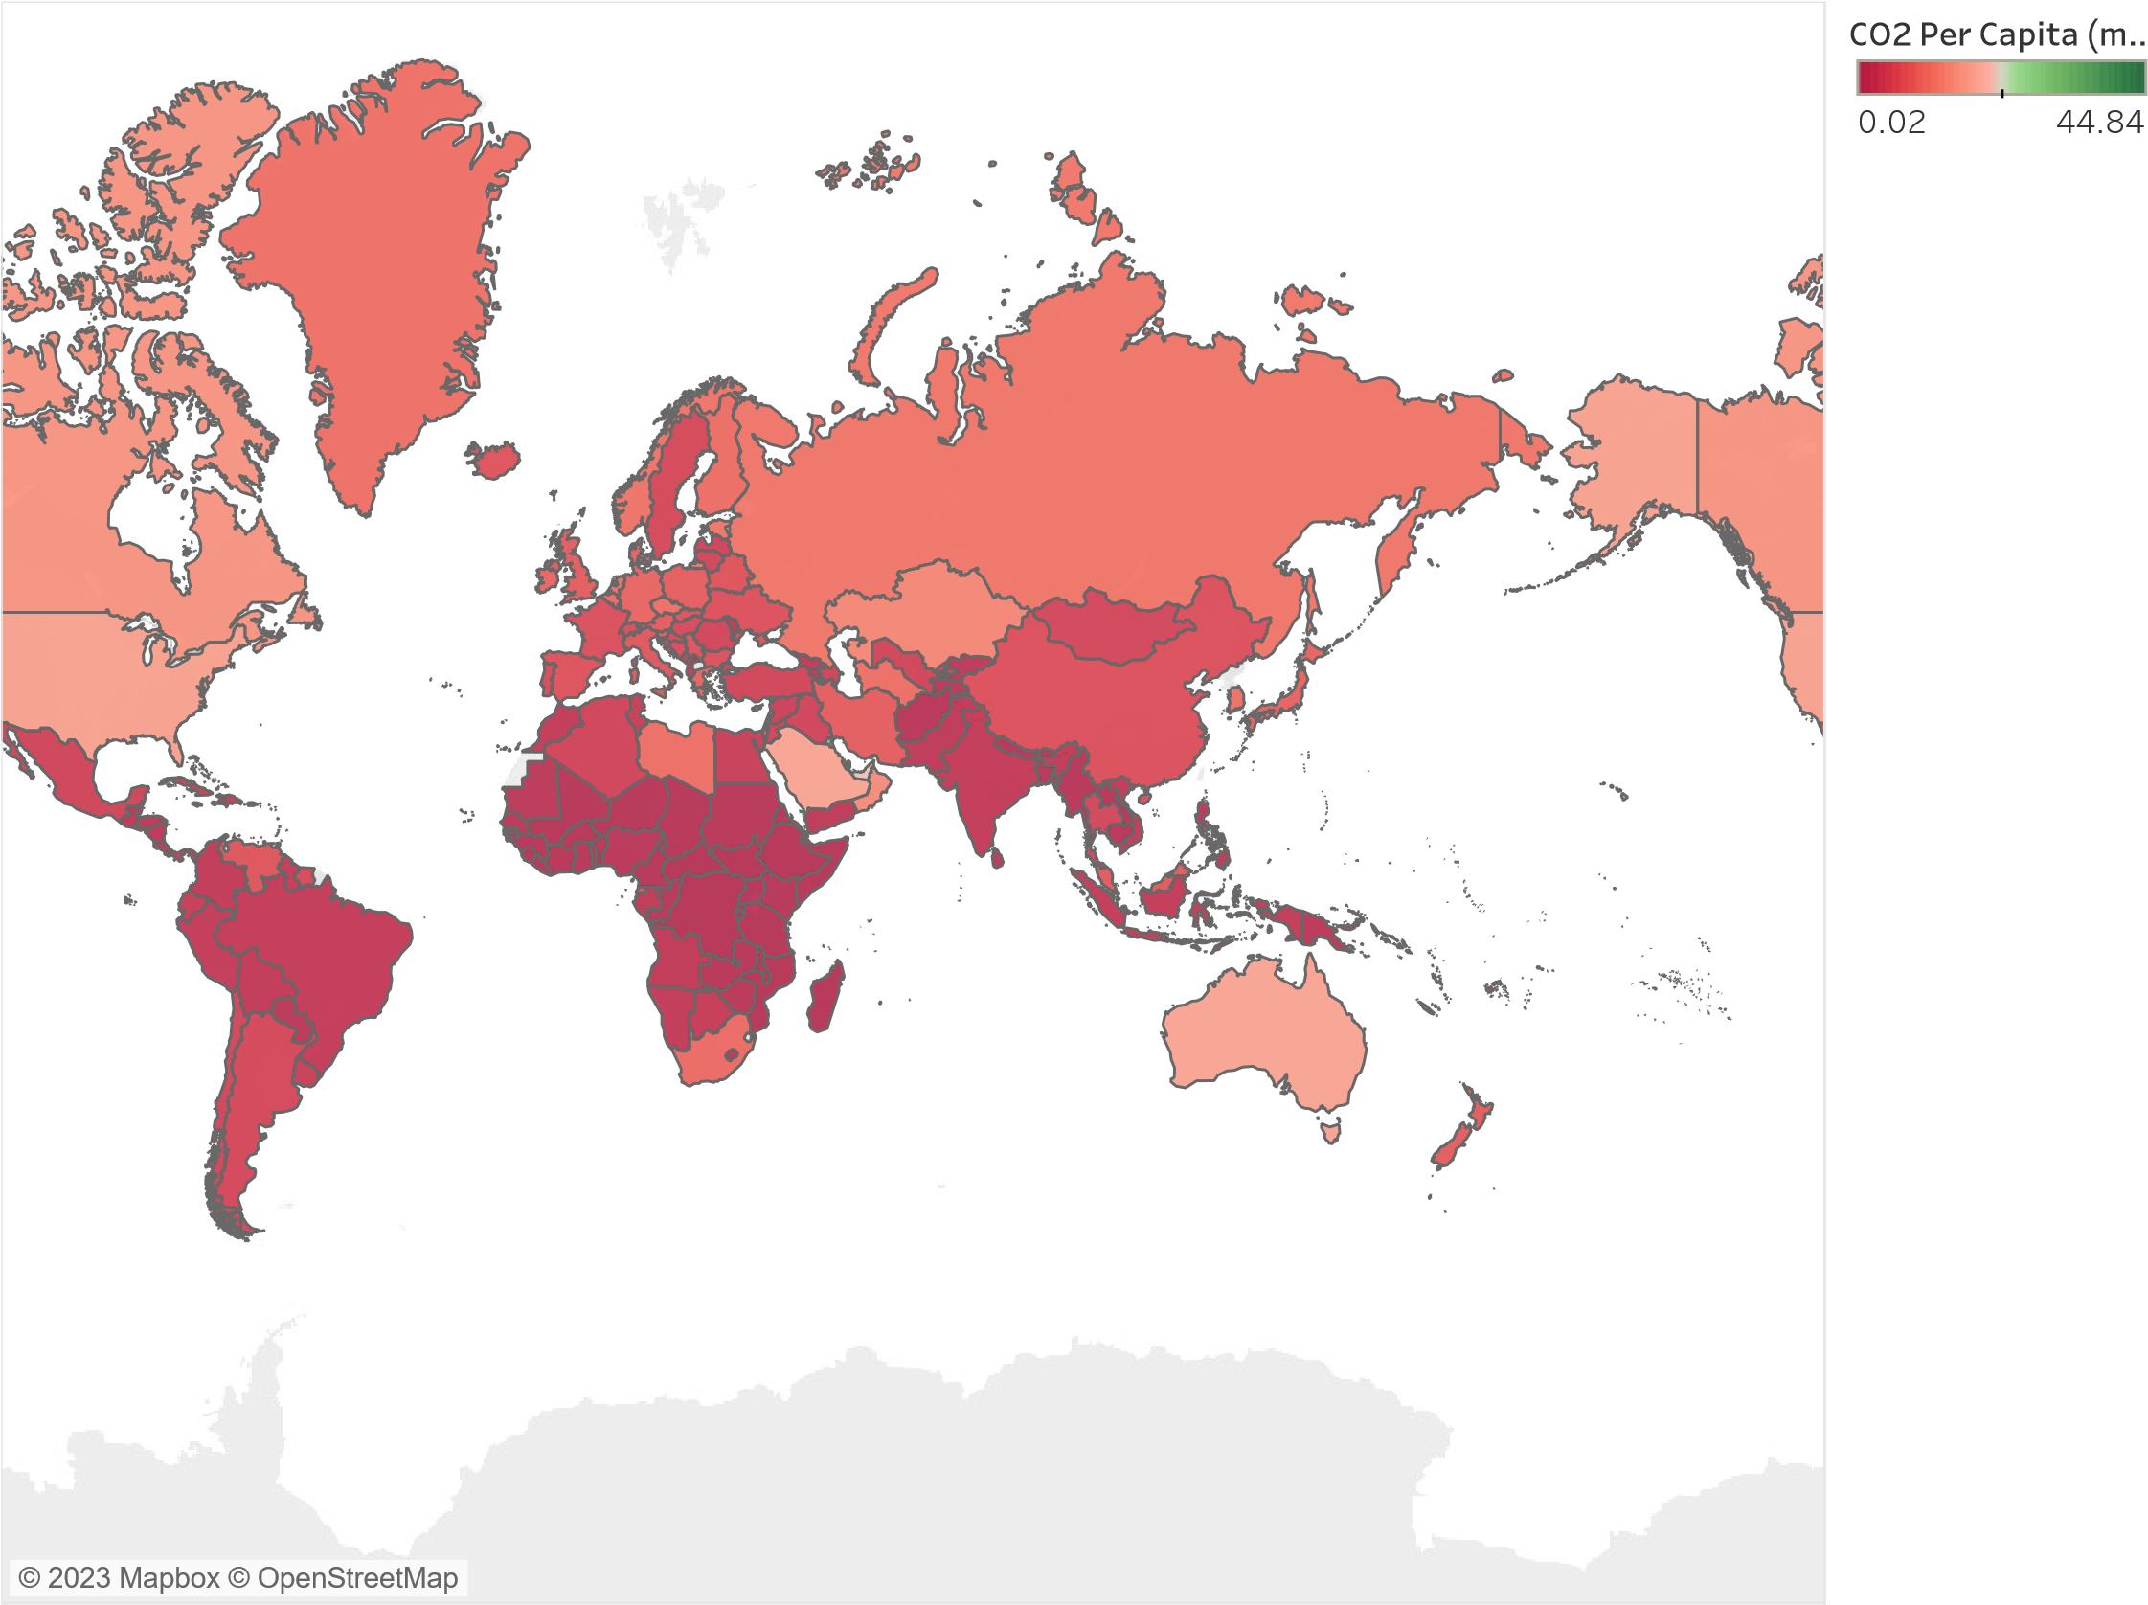

Map based on Longitude (generated) and Latitude (generated). Color shows sum of CO2 Per Capita (metric tons).

Details are shown for Country Name. The data is filtered on Year Year, which keeps 2009.